JAVA ASSIGNMENT 2



SUBMITTED TO ::Mrs Sheerin Zandoo

SUBMITTED BY::

Deepanshu Chajgotra

CSE(A1)

1628/A1

4 Semester

CONDITIONS FOR THE MINI PROJECT

**Micro Project: Student Recommender System**

**Problem Statement: A system is needed which recommends the**

**Placement Officer the students who have 0 backlog count and have overall**

**percentage more than 60%. This system will help placement officer to**

**further groom the recommended students and align them for the various**

**companies’ placement requirements which comes to Campus. Following**

**artifacts should be prepared in Google Document submission:**

**1. Requirements Specification: A list of requirements specifications**

**which student will frame based on what they perceive from the high**

**level problem statement. List should not contain more than 5 Use**

**Cases 1 Marks**

**2. Design Specification: Class diagram &amp; Sequence Diagram for the**

**defined problem statement should be prepared in the Draw.io tool**

**and prepared images should be added in the main Google**

**Document. Diagrams should be easy to understand with proper notes**

**in it. Not more than 2 pages for this section. 2**

**Marks**

**3. Program Specification: This section should contain only the**

**important algorithms / functions logic. Not more than 3 pages for this**

**section. 2 Marks**

**4. Implementation: Create one GitHub Repository and commit your**

**complete code implementation in the repository. Copy paste the link**

**of the GitHub Code in the document 2 Marks**

**5. Testing: Unit Testing Specifications and execution logs should be**

**prepared. Execution logs must contain the problems students faced**

**during compilation and execution and how they resolved it. Not more**

**than 3 pages for this section. 2 Marks**

**6. Demo: Students should be able to create the video of the working**

**demo and should upload it in YouTube. Once uploaded the link of the**

**video should be added in the document. Just copy paste the link in**

**this section.**

* CLASS DIAGRAM

In [software engineering](https://en.wikipedia.org/wiki/Software_engineering), a **class diagram** in the [Unified Modeling Language](https://en.wikipedia.org/wiki/Unified_Modeling_Language) (UML) is a type of static structure diagram that describes the structure of a system by showing the system's [classes](https://en.wikipedia.org/wiki/Class_(computer_science)), their attributes, operations (or methods), and the relationships among objects.

The class diagram is the main building block of [object-oriented](https://en.wikipedia.org/wiki/Object-oriented_programming) modeling. It is used for general [conceptual modeling](https://en.wikipedia.org/wiki/Conceptual_model) of the structure of the application, and for detailed modeling translating the models into [programming code](https://en.wikipedia.org/wiki/Programming_code). Class diagrams can also be used for [data modeling](https://en.wikipedia.org/wiki/Data_modeling).[[1]](https://en.wikipedia.org/wiki/Class_diagram#cite_note-1) The classes in a class diagram represent both the main elements, interactions in the application, and the classes to be programmed.

FOR THIS PROGRAM THE CLASS DIAGRAM IS :-

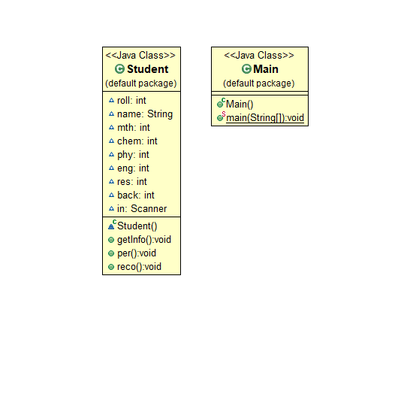

* SEQUENCE DIAGRAM

A **sequence diagram** simply depicts interaction between objects in a **sequential** order i.e. the order in which these interactions take place. We can also use the terms event **diagrams** or event scenarios to refer to a **sequence diagram**. **Sequence diagrams** describe how and in what order the objects in a system function.

FOR THIS PROGRAM THE SEQUENCE DIAGRAM IS:-

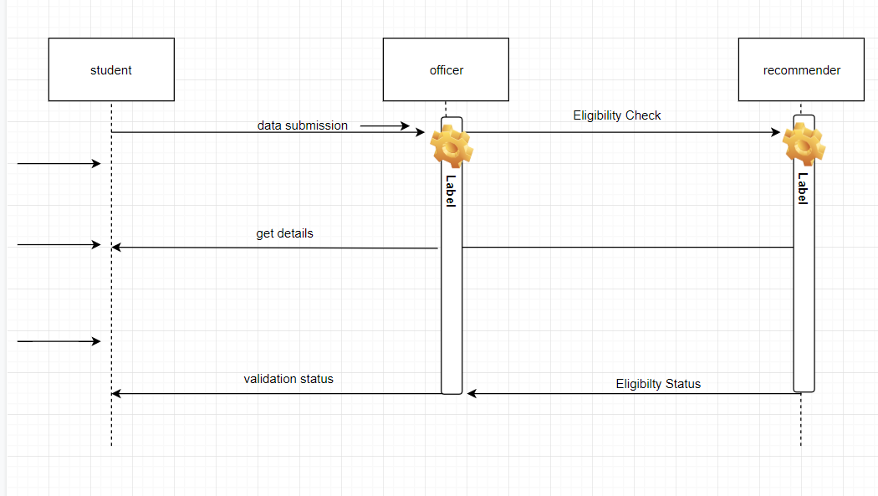

SOURCE CODE

import java.util.*;

class Student

{

int roll;

String name;

int mth;

int chem;

int phy;

int eng;

int res;

int back;

Scanner in = new Scanner(System.in);

public void getInfo()

{

System.out.println("enter the name and roll no.:");

name = in.next();

roll = in.nextInt();

System.out.println("enter the marks of all years (out of 100)");

mth = in.nextInt();

chem = in.nextInt();

phy = in.nextInt();

eng = in.nextInt();

System.out.println("Enter the no. of the backlogs left");

back = in.nextInt();

}

public void per()

{

int add= mth+chem+phy+eng;

res=add/4;

System.out.println("the result of the student is ="+res+"%");

}

public void reco()

{

if (mth>=40 && chem>=40 && phy>=40 && eng>=40 && back==0 && res>=60)

{

System.out.println (name+" is recommended to the company");

}

else

{

System.out.println (name+" is recommended not to the company");

}

}

}

public class Main

{

public static void main (String[]args)

{

Scanner in = new Scanner(System.in);

System.out.println("enter the number of Student in database");

int n = in.nextInt();

ArrayList<Student> al = new ArrayList<Student>();

for(int i=0; i<=n; i++)

{

Student s = new Student();

s.getInfo();

s.per();

s.reco();

al.add(s);

}

}

}